PROJECT REPORT

# Fertilizers Recommendation for Disease Prediction

**Team ID:** PNT2022TMID22643

**Team Leader** : Arulesh 732919CSR014

**Team Member** : Monisadeve 732919CSR062

**Team Member** : Mukeshkumar 732919CSR063

**Team****Member:**Aaronludejennith732919CSR001

## INTRODUCTION :

* **Agriculture is the most important sector in today’s life. Most plants are affected by a wide variety of bacterial and fungal diseases. Diseases on plants placed a major constraint on the production and a major threat to food security. Hence, early and accurate identiﬁcation of plant diseases is essential to ensure high quantity and best quality. In recent years, the number of diseases on plants and the degree of harm caused has increased due to the variation in pathogen varieties, changes in cultivation methods, and inadequate plant protection techniques.**

## Project Overview

* **An Automated system is introduced to identify different diseases on plants by checking the symptoms shown on the leaves of the plant.Deep learning techniques are used to identify the diseases and suggest the precautions that can be taken for those diseases changes in cultivation method and inadequate**

plant protection techniques and suggest all the precautions that can be taken for those diseases.

## Purpose

* **To Detect and recognize the plant diseases and to recommend fertilizer, it is necessary to identify the diseases and to recommend to get different and useful features needed for the purpose of analyzing later.**
* **To provide symptoms in identifying the disease at its earliest. Hence the authors proposed and implemented new fertilizers Recommendation System for Crop Disease Prediction.**

# LITREATURE SURVEY

## Existing Problem

* **Adequate mineral nutrition is central to crop production. However, it can also exert considerable Inﬂuence on disease development. Fertilizer application can increase or decrease development of diseases caused by different pathogens, and the mechanisms responsible are complex, including effects of nutrients on**

plant growth, plant resistance mechanisms and direct effects on the pathogen. The effects of mineral nutrition on plant disease and the mechanisms responsible for those effects have been dealt with comprehensively elsewhere. In India, around 40% of land is kept and grown using reliable irrigation technologies, while the rest relies on the monsoon environment for water. Irrigation decreases reliance on the monsoon, increases food security, and boosts agricultural production.

* **Most research articles use humidity, moisture, and temperature sensors near the plant's root, with an external device handling all of the data provided by the sensors and transmitting it directly to an Android application. It was created to measure the approximate values of temperature, humidity and moisture sensors**

that were programmed into a microcontroller to manage the amount of water.

## References :

* **Reyes Angie .K, Juan C. Caicedo, and Jorge E. Camargo, "Fine-tuning Deep Convolutional Networks for Plant Recognition", In CLEF (Working Notes), 2015.**
* **Hamrouni .L, Aiadi .O, Khaldi .B and Kherﬁ .M.L, "Plants Species Identiﬁcation using Computer Vision Techniques", Revue des Bioressources 7, no. 1, 2018.**
* **Naresh, Y. G., and H. S. Nagendraswamy, "Classiﬁcation of medicinal plants: an approach using modiﬁed LBP with symbolic representation", Neurocomputing 173, pp: 1789-1797, 2016.**

## Problem Statement Deﬁnition :

* **The solution to the problem is Machine learning, which is one of the applications of Artiﬁcial Intelligence, is being used to implement the proposed system. Crop recommendation is going to recommend you the best crop you can grow in your land as per the soil nutrition value and along with as per the climate in that region. And recommending the best fertilizer for every particular crop is also a challenging task. And the other and most important issue is when a plant gets caught by heterogeneous diseases that effect on less amount of agriculture production and compromises with quality as well. To overcome all these issues this recommendation has been proposed .**
* **Nowadays a lot of research and work is being implemented in the smart and modern agriculture domain. Crop recommendation is characterized by a soil database comprised of Nitrogen, Phosphorus, potassium. The ensembles technique is used to build a recommendation model that combines the prediction of multiple machine learning. Models to recommend the right crop based on soil value and the best fertilizer to use.**

## IDEATION & PROPOSED SOLUTION :

**Empathy Map Canvas :**

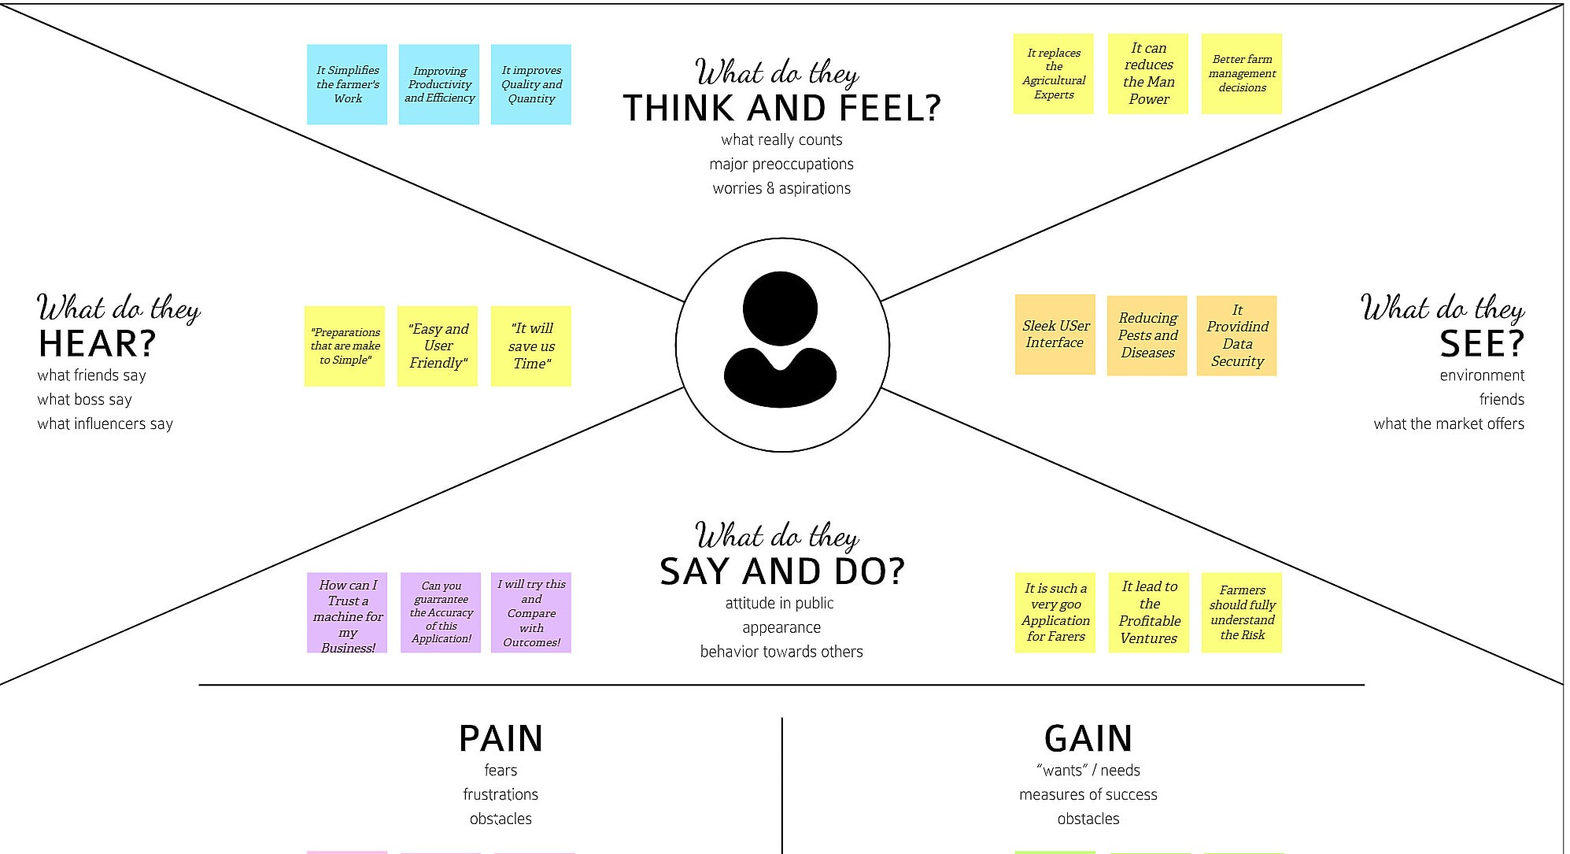

## Ideation & Brainstorming :

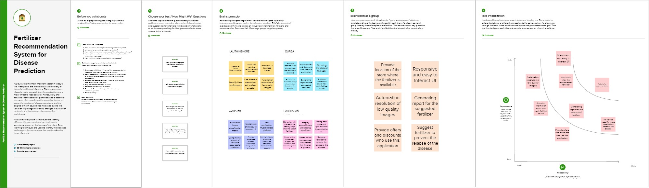

**Proposed Solution :**

* **The idea of the proposed solution uses Deep learning and Machine algorithm to classify leaves and identify the diseases and siggest the fertilizers. The deep learning process includes the MobileNetV2 and VGG19 training Models.**
* **Based on the leaf disease detected , the model recommendation for fertilizers for the prevention. The farmers and researchers are the end users get beneﬁed by the system.**
* **More accurate in others. The system is more robust corporating more image data sets with wider variations. This system also estimates the probability of infected plant.**
* **Plant growth can be enhanced. Ensure plants are getting supplied with every nutrient they need also and multiple cross in grow in every yields for every season. It also helps people's nutritional needs.**

## Problem Solution Fit

* **This Learn and Build phase has proven to be the most important, parallel phase that successful startups follow. It contains the very ﬁrst activity that startups should follow if they have an idea: Find prospective customers to talk to. Usually, this idea is already translated to a software product, which should always be a Minimum Viable Product (MVP) a version of the product that requires the least amount of development time with a minimum amount of effort.**
* **An MVP is based on requirements desired by potential customers, but to obtain these requirements, the startup should talk as early as possible with those customers. The startup then requires to prioritise the ‘must haves’, which are the minimum necessary requirements for the MVP. Once the MVP is ready for customer feedback, the second most important activity is performed by the startup foreveryone.**

## REQUIREMENT ANALYSIS :

Functional Requirements

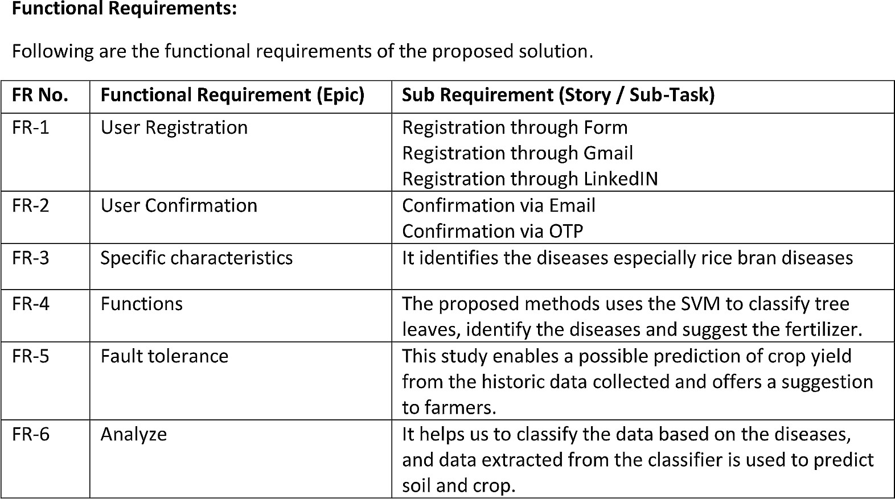

Non Functional Requirements

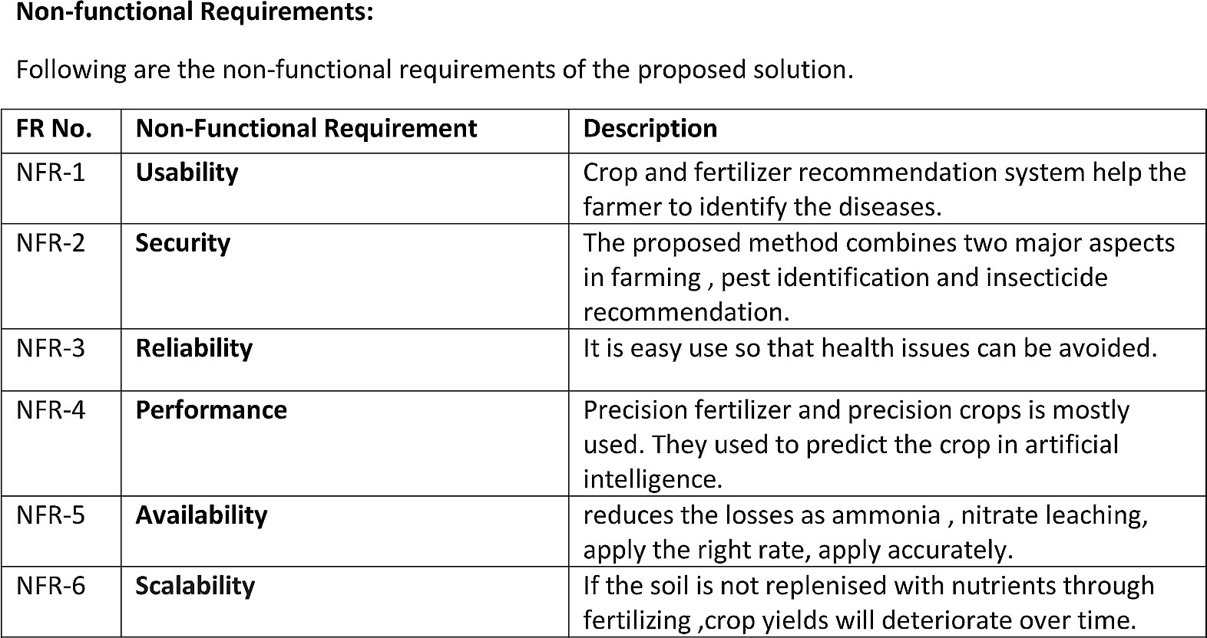

## PROJECT DESIGN :

Solution & Technical Architecture

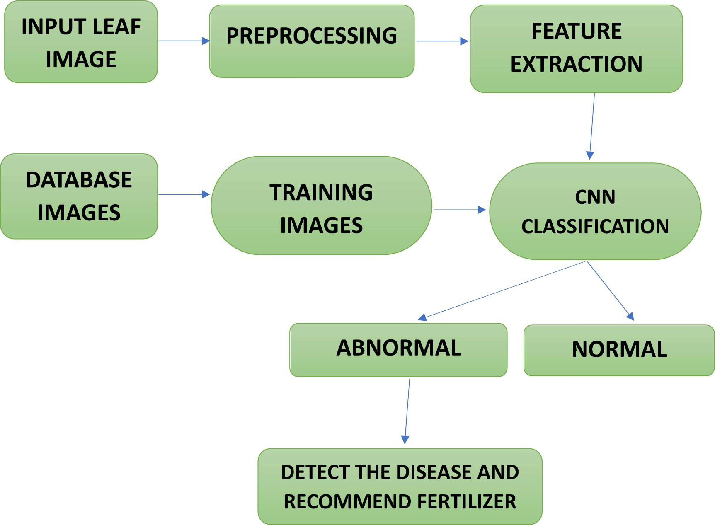

Data Flow Daigrams

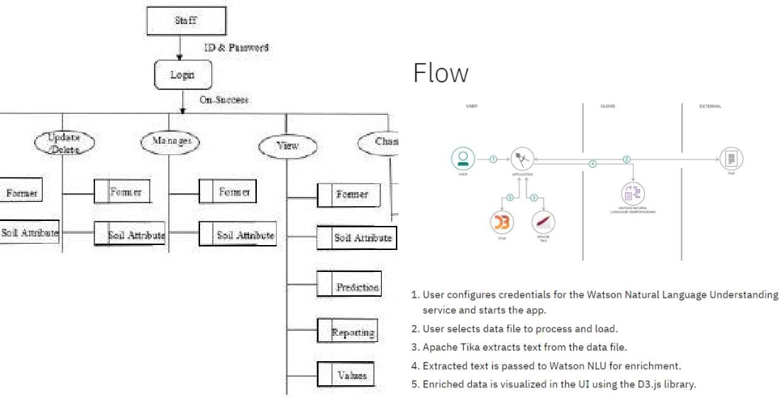

User Stories

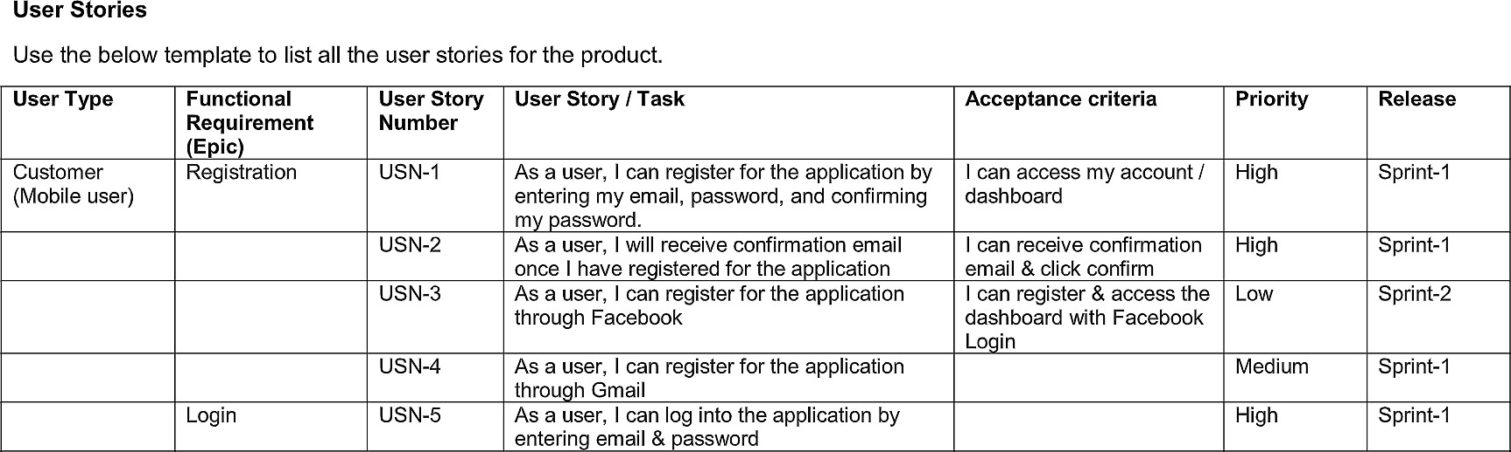

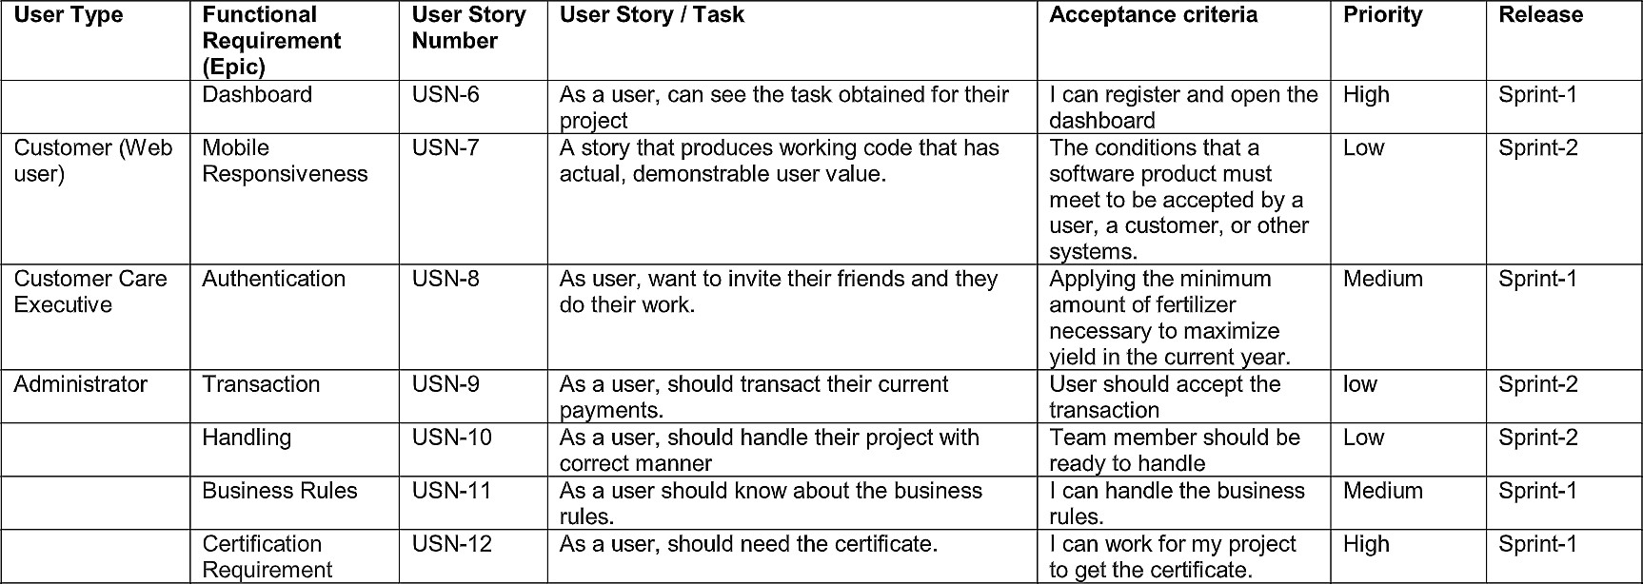

## PROJECT PLANNING & SCHEDULING :

Sprint Planning and Estimation

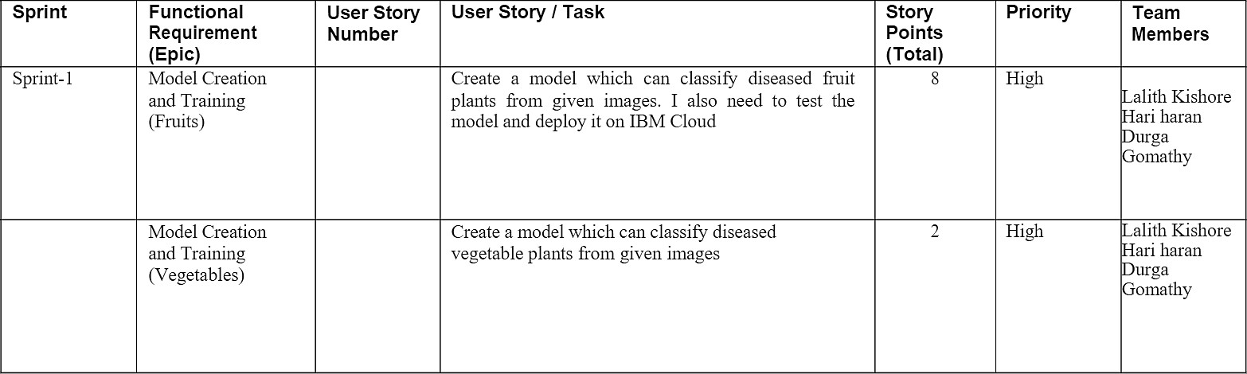

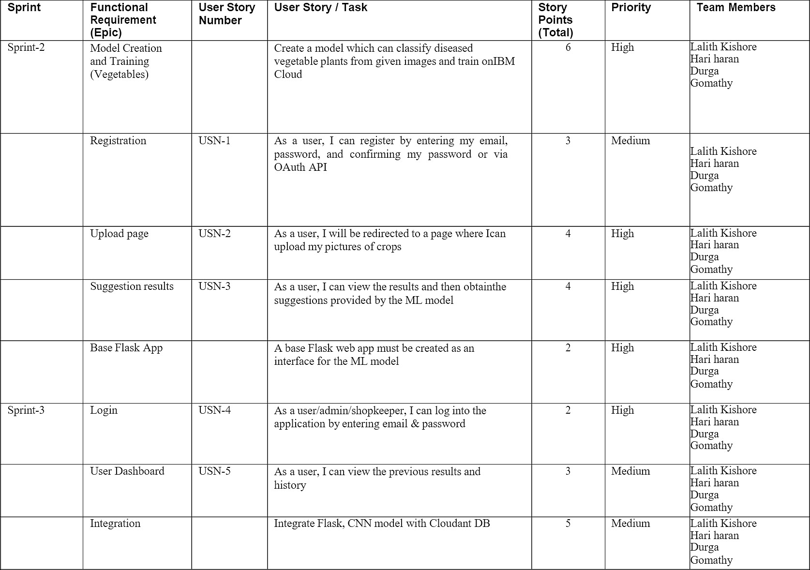

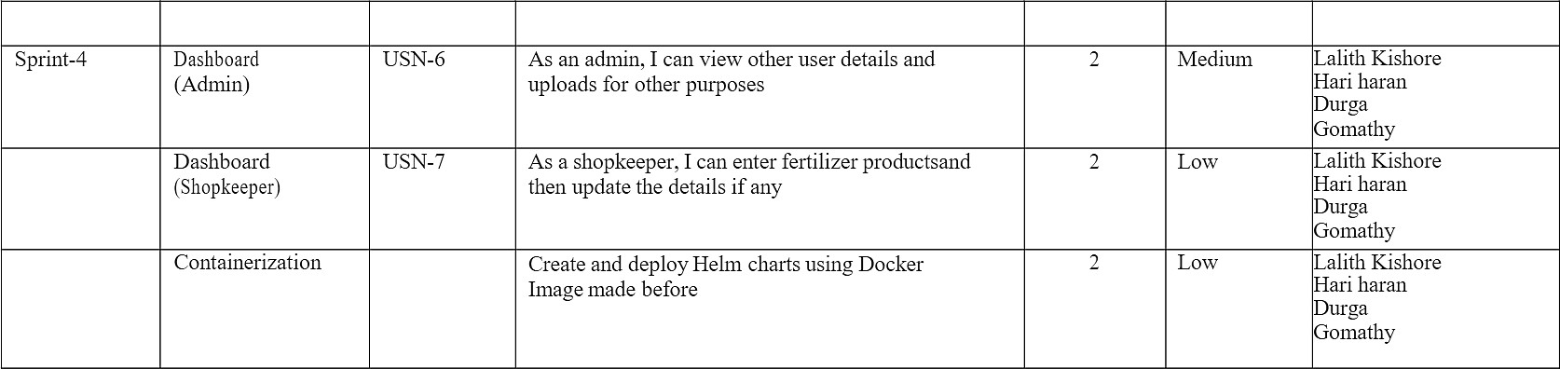

Sprint Delivery Schedule

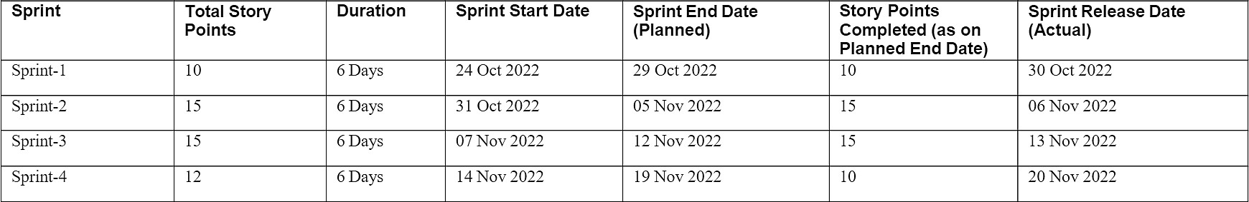

Reports from JIRA



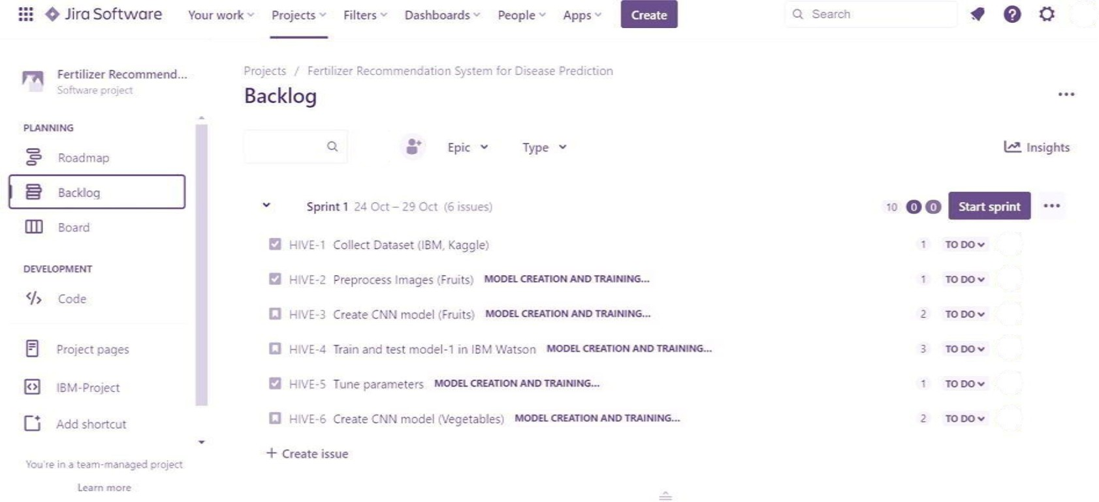

## CONCLUSION :

* **The core strategy of this project is to predict the crop based on the soil nutrient content and the location where the crop is growing. This system will help he farmers to choose the right crop for their land and to give the suitable amount of fertilizer to produce the maximum yield. The Support Vector Machine algorithm helps to predict the crop the precisely based on the pre-processed crop data. This system will also help the new comers to choose the crop which will grow in their area and produce them a good proﬁt. A decent amount of proﬁt will attract more people towards the agriculture.**

## FUTURE SCOPE :

* **This further research is implementing the proposed algorithm with the existing public datasets. Also, various segmentation algorithms can be implemented to improve accuracy. The proposed algorithm can be modiﬁed further to identify the disease that affects the various plant organs such as vegetables and fruits.**

**Github I'd :** **https://github.com/IBM-EPBL/IBM-Project-32763-1660211978**

# Project Demo Link :https://youtu.be/VS37dxcgC08

**Data Set (in google drive):** **https://drive.google.com/drive/folders/1j_sYmIN9aNZzps7TRIM0rYJT6pZI9SyV?usp=share_link**